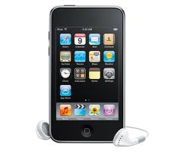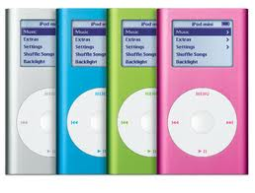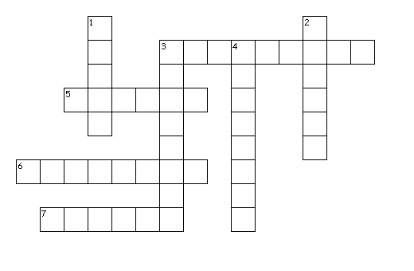

Across

3. I don't want my mobile phone to ring while I’m in the theatre. I think it’s best to _______it _____.

5. I want to listen to the news, but the radio’s too quiet.Can you ______it _____ please?

6. When you have done that, you can ________it _____ and watch the show.

7. Of course the Tv isn’t working. You forgot to connect it to the power supply. You have to ________it ___.

Down

1. When I got my new PC, out of its box, it wasn’t ready to use. I had to _____it _____.

2. If you want to know the price of the ticket for the concert, you can ________ it _____ on the internet.

3. This computer game has stopped working. I’m going to ______ it ____and start it again to see if it works.

4. Mum thinks your DVD player is too loud. She wants you to ________it _____.



Turn up / down set up look up

switch on / off shut down plug in